LEVEL 1 — FINANCIAL MARKETS FOUNDATIONS
Financial Market Structure, Asset Classes & Trading Mechanics
This is the expanded reference edition of the three Level 1 topics that open the curriculum's Financial Markets Foundations track. Each topic keeps its original learning-position summary and then goes substantially deeper: diagrams of how markets and trades actually work, reference tables with real conventions and figures, worked numerical examples with full arithmetic, and charts quantifying scale, cost and risk. Figures without a cited source are illustrative, constructed for teaching purposes and clearly labelled as such.

Table of Contents
Right-click and choose “Update Field” (or “Update entire table”) after opening in Word to populate page numbers.
Table of Contents 1
1. Financial Market Structure (Level 1) 1
1.1 Learning Position at a Glance 1
1.2 The Structure of Financial Markets 1
Exchanges vs OTC Markets vs ATSs 1
Primary vs Secondary Markets 1
1.3 Market Participants — Reference Table 1
1.4 The Trade Lifecycle 1
What Happens at Each Stage 1
1.5 Settlement Timelines Have Been Shrinking 1
1.6 Where the Trading Actually Happens: Market Size by Venue Type 1
1.7 Central Clearing & the CCP — Why Novation Exists 1
1.8 Worked Exercise — Model Answer 1
1.9 Common Mistakes — Why They Actually Matter 1
1.10 Professional Applications 1
2. Asset Classes (Level 1) 1
2.1 Learning Position at a Glance 1
2.2 The Asset Class Landscape 1
2.3 Reference Table — Model Answer to the Practical Exercise 1
2.4 Deep Dive: Bonds Quote and Move Differently From Equities 1
2.5 Deep Dive: Funding and Carry in Perpetual Futures and FX 1
2.6 Common Mistakes — Deeper Look 1
2.7 Professional Applications 1
3. Trading Mechanics (Level 1) 1
3.1 Learning Position at a Glance 1
3.2 Core Vocabulary — Definitions, Formulas and Micro-Examples 1
3.3 Fully Worked Example — Leveraged Futures Position P&L 1
3.4 Leverage and Margin Across Products 1
3.5 The Bid-Ask Spread: The Cost Beginners Forget 1
3.6 Funding, Carry and Basis — Worked Examples 1
3.7 Common Mistakes — Deeper Look 1
3.8 Professional Applications 1

1. Financial Market Structure (Level 1)
Covers: Exchanges · OTC markets · primary/secondary markets · brokers/dealers · prime brokers · clearing houses · settlement · custodians · CCPs · electronic venues

1.1 Learning Position at a Glance
- What it is: The plumbing of financial markets — who trades with whom, where, and how a trade becomes a settled position.
- Why it matters: Every later topic (execution, microstructure, risk) assumes you know where and how trades actually happen.
- Prerequisites: None.
- Connects to Research: Determines what data is available and how clean/complete it will be (exchange-traded vs OTC).
- Connects to Development: Determines what APIs and data feeds you will integrate with, and what settlement/clearing constraints a system must respect.
- Connects to Trading: Determines counterparty risk, settlement timing, and which venues a strategy can actually access.
- Practical exercise: Write a one-page comparison of how a trade in a listed equity, an OTC FX forward, and a centrally-cleared future differs from order placement to settlement. (A full model answer is worked through in §1.7.)
- Common beginner mistakes:
  - Assuming all markets are as transparent and liquid as listed equities.
  - Ignoring settlement/clearing timelines when reasoning about risk.
- Advanced extensions: Central clearing mandates post-2008 reform, cross-margining, and venue fragmentation.
- Professional applications: Venue selection for execution algorithms; counterparty risk assessment; regulatory reporting.

1.2 The Structure of Financial Markets
A financial market is not a single place — it is a layered system of participants, intermediaries, venues and post-trade infrastructure. Understanding this layering is what lets you answer questions like “who actually bears the risk if my counterparty defaults?” and “why does my broker route my order somewhere I didn't choose?” The diagram below traces a trade from the initiating investor down to a settled, custodied position.
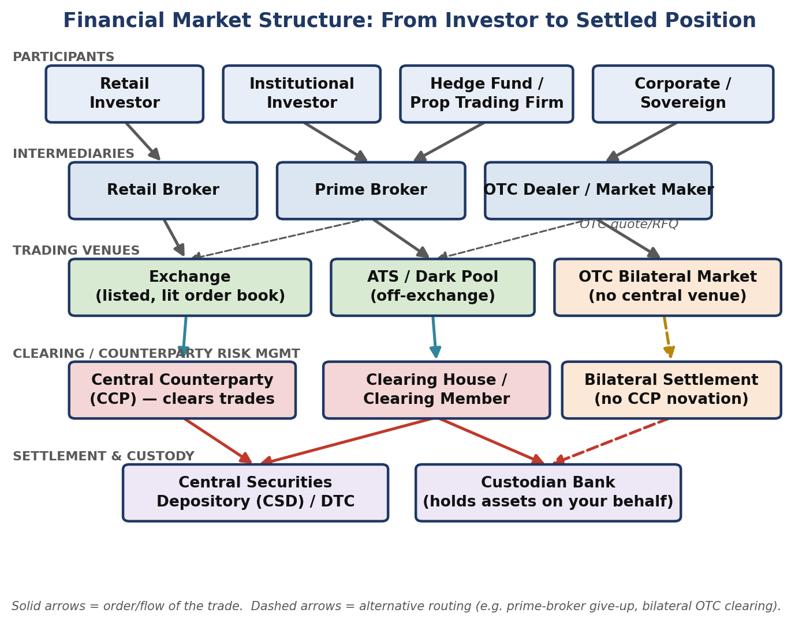
Figure 1.1 — The five layers of financial market structure: participants, intermediaries, trading venues, clearing/counterparty-risk management, and settlement/custody. Dashed arrows show alternative routing (e.g. a prime broker “giving up” a trade to another executing broker, or bilateral OTC clearing that never touches a CCP).

Exchanges vs OTC Markets vs ATSs
- Exchanges: Centralised, regulated venues (NYSE, LSE, CME, Deutsche Börse) with a public, rule-based limit order book. Prices and, in most jurisdictions, post-trade volumes are publicly disseminated in real time. Listing standards and market surveillance apply.
- Alternative Trading Systems (ATSs) / dark pools: Off-exchange, typically non-displayed (“dark”) venues that match orders without showing a public quote before execution, aiming to reduce market impact for large orders. Post-trade reporting is still generally required, but pre-trade transparency is deliberately limited.
- OTC (over-the-counter) markets: No central venue at all — participants trade bilaterally, typically through a dealer who quotes a price on request (RFQ). Most FX, most interest-rate swaps, and much of the corporate bond market trade this way. Price transparency depends entirely on how many dealers you query.

Primary vs Secondary Markets
- Primary market: Where a security is created and sold for the first time — an IPO, a bond issuance, a follow-on equity offering. The issuer receives the proceeds.
- Secondary market: Where previously-issued securities trade between investors — the issuer is not a party to the trade and receives no proceeds. Essentially all day-to-day trading discussed in this curriculum happens in the secondary market.

1.3 Market Participants — Reference Table
Each layer in Figure 1.1 is populated by a distinct type of institution with a distinct economic role and revenue model:
Participant | Primary Role | How It Makes Money | Example
Broker | Executes orders on behalf of a client; does not take the other side of the trade itself (agency model). | Commissions / execution fees. | A retail brokerage routing a client's equity order to an exchange.
Dealer / Market Maker | Takes the other side of client trades from its own book (principal model), continuously quoting bid and ask prices. | The bid-ask spread, plus any directional P&L on inventory. | An OTC FX dealer quoting EUR/USD to a corporate client.
Prime Broker | Provides financing, securities lending, custody and consolidated reporting to institutional clients (typically hedge funds), and can “give up” executed trades to be settled under the PB relationship. | Financing spreads, securities-lending fees, and commissions. | A bank's prime services division financing a hedge fund's long/short equity book.
Clearing House / CCP | Interposes itself between the two sides of a trade (novation), becoming the buyer to every seller and the seller to every buyer, and mutualises default risk via margin and a default fund. | Clearing fees; margin is collected as risk protection, not revenue. | LCH, CME Clearing, ICE Clear.
Custodian | Safekeeps client assets, handles corporate actions (dividends, splits), and settles trades on behalf of institutional clients. | Custody and asset-servicing fees, typically a small basis-point charge on assets under custody. | State Street or BNY Mellon holding a pension fund's securities.
Central Securities Depository (CSD) | The ultimate electronic book-entry record of who owns what; where legal ownership actually changes hands on settlement. | Settlement and safekeeping fees charged to participants. | The Depository Trust Company (DTC) in the US; Euroclear/Clearstream in Europe.
Electronic Venue / ATS | Provides the technology and rulebook for matching buy and sell orders, lit or dark. | Transaction/market-data fees; sometimes rebates for adding liquidity. | An equity dark pool operated by a bank or independent venue operator.

1.4 The Trade Lifecycle
Every trade, regardless of asset class, passes through the same conceptual stages — though the actors and timing differ sharply between a centrally-cleared exchange trade and a bilateral OTC trade.
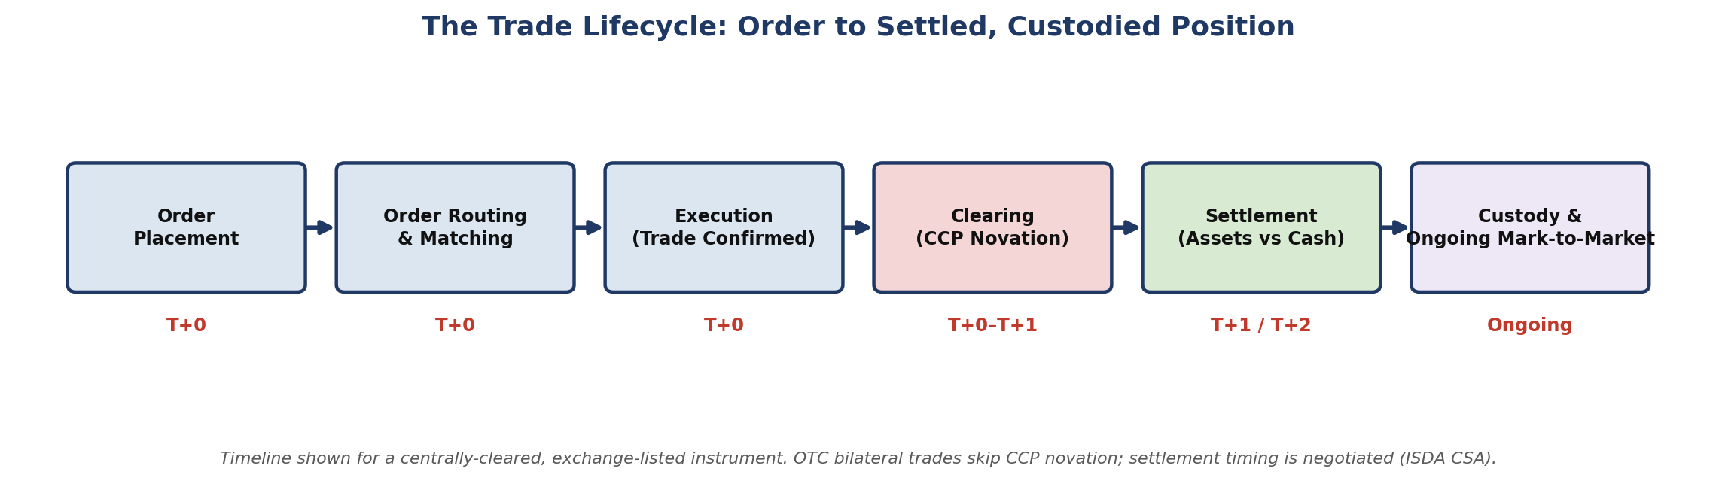
Figure 1.2 — The trade lifecycle for a centrally-cleared, exchange-listed instrument. An OTC bilateral trade skips the CCP-novation step entirely and settles or collateralises according to a negotiated ISDA Credit Support Annex (CSA).

What Happens at Each Stage
- Order placement: The investor (or their algorithm) specifies instrument, side, size, price/type and sends it to a broker.
- Order routing & matching: The broker routes the order to a venue (its own exchange, an ATS, or an internal matching engine), where it either rests on the book or matches against existing liquidity.
- Execution: A trade is confirmed: both counterparties (or the counterparty and the venue) now have a legally binding obligation.
- Clearing (CCP novation): For centrally-cleared products, the CCP steps in as legal counterparty to both sides, so each participant now faces the CCP's credit risk rather than the original counterparty's. Initial margin is posted at this stage.
- Settlement: Securities and cash are actually exchanged, with legal ownership transferred at the CSD. This is now T+1 for most US securities (see Figure 1.3).
- Custody & ongoing mark-to-market: The position is held by a custodian (or the broker, for retail accounts) and marked to market daily for P&L and margin purposes for as long as it is held.

1.5 Settlement Timelines Have Been Shrinking
Settlement timing is not a historical accident — it is a direct, regulated trade-off between operational feasibility and counterparty/systemic risk: the longer a trade sits unsettled, the more can go wrong (a counterparty default, a large adverse price move) before it is finalised.
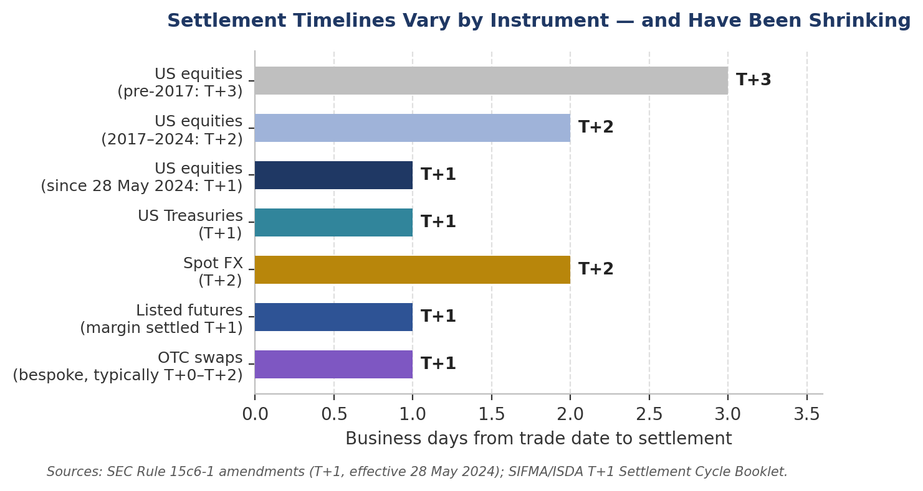
Figure 1.3 — US equities moved from T+3 to T+2 in September 2017, and from T+2 to T+1 on 28 May 2024 under SEC Rule 15c6-1, explicitly to reduce the systemic risk from unsettled trades. OTC swaps settle or post collateral on a bespoke, negotiated basis.
⚠ Why shorter settlement matters for risk, not just convenience
- The SEC's own stated rationale for the 2024 move to T+1 was to reduce credit, market and liquidity risk from unsettled trades — not merely operational efficiency (SEC Chair Gary Gensler, 2024 statement).
- A shorter settlement window shrinks the time an investor is exposed to their broker's or counterparty's solvency — directly relevant when reasoning about counterparty risk in §1.6 below.

1.6 Where the Trading Actually Happens: Market Size by Venue Type
The scale of OTC markets is easy to underestimate from a retail vantage point, where exchange-listed equities dominate everyday experience. In reality, OTC markets — FX above all — dwarf listed-exchange turnover in daily dollar terms.
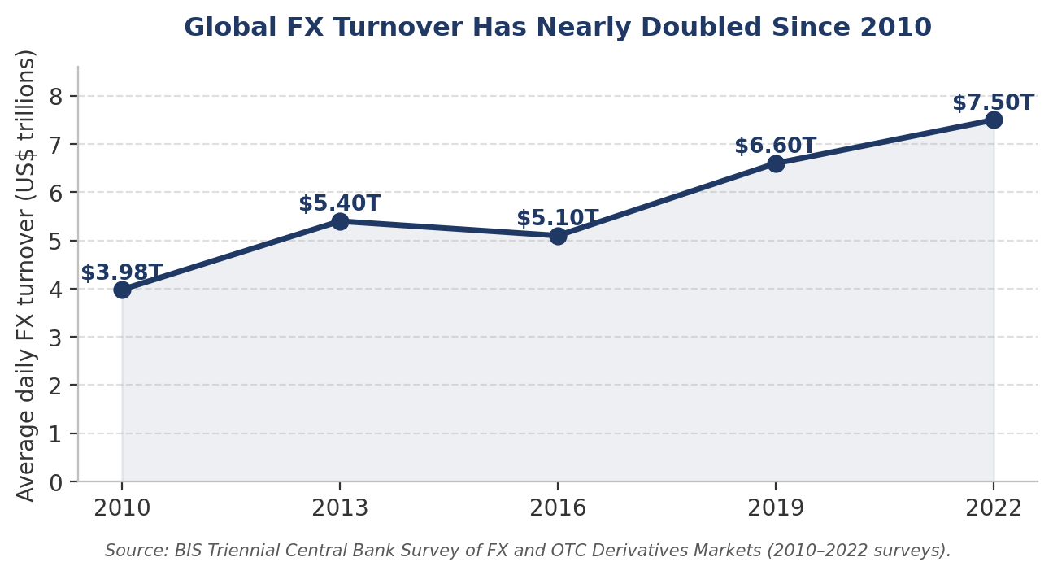
Figure 1.4 — Global FX turnover, almost entirely OTC, reached $7.5 trillion per day in April 2022 — nearly double its 2010 level. Source: BIS Triennial Central Bank Survey.
By comparison, combined global equity exchange turnover — while large in absolute terms — is a small fraction of daily FX turnover, illustrating how much of global financial activity happens away from a public, lit order book.

1.7 Central Clearing & the CCP — Why Novation Exists
Central clearing solves a specific problem: bilateral counterparty risk. Without a CCP, if you buy a future from Counterparty A, you are exposed to A's solvency until the contract expires or you close the position. With a CCP, the moment your trade is confirmed, the CCP legally substitutes itself as your counterparty (a process called novation) — you are now exposed to the CCP, not to A, and A is exposed to the CCP, not to you.
- Initial margin: Collateral posted upfront, sized to cover the CCP's expected worst-case loss on the position over the time it would take to close it out if you defaulted (commonly calibrated to a 1–5 day, 99%+ confidence loss).
- Variation margin: Collateral exchanged daily (sometimes intraday) to cover the mark-to-market change in the position's value — this is what keeps a CCP's own exposure close to zero at all times.
- Default fund / mutualisation: A pooled resource, funded by all clearing members, that absorbs losses beyond a defaulting member's own margin — the mechanism that makes a CCP's guarantee credible even in extreme scenarios.
⚠ Post-2008 reform: why so much OTC trading is now centrally cleared
- Before the 2008 financial crisis, most OTC derivatives (interest-rate swaps, credit default swaps) settled bilaterally with no CCP — a key reason AIG's default risk propagated so widely through the system.
- The 2009 G20 Pittsburgh commitments required standardised OTC derivatives to be centrally cleared; in the US this was implemented via Title VII of the Dodd-Frank Act, and in the EU via EMIR (the European Market Infrastructure Regulation).
- The practical effect for a modern quant: a large and growing share of what used to be purely bilateral OTC risk (e.g. standard interest-rate swaps) now flows through the same CCP-novation mechanism as exchange-listed futures.

1.8 Worked Exercise — Model Answer
Exercise: Compare how a trade in a listed equity, an OTC FX forward, and a centrally-cleared future differs from order placement to settlement.
Stage | Listed Equity (e.g. AAPL on Nasdaq) | OTC FX Forward (e.g. 3-month EUR/USD) | Centrally-Cleared Future (e.g. CME ES)
Venue | Public exchange, lit central limit order book. | No venue — bilateral quote from a dealer (or an electronic RFQ platform). | Public exchange (CME Globex), lit central limit order book.
Price discovery | Continuous, publicly displayed best bid/offer. | Only visible to the parties who requested a quote; no consolidated public tape. | Continuous, publicly displayed best bid/offer.
Counterparty | Unknown anonymous counterparty matched by the exchange. | The specific dealer you traded with — known and named. | Unknown anonymous counterparty matched by the exchange.
Clearing | Novated to a CCP (e.g. NSCC) automatically and immediately. | Typically not novated to a CCP; bilateral credit exposure persists for the life of the forward (unless voluntarily cleared). | Novated to CME Clearing (a CCP) immediately upon execution.
Margin | None for a fully-paid cash purchase; margin applies only if bought on margin. | Bilateral collateral (if any) governed by a negotiated ISDA CSA — terms vary by counterparty. | Initial margin posted to the CCP at trade inception; variation margin daily.
Settlement | T+1 (US, since 28 May 2024): shares and cash exchanged via the CSD (DTC). | On the forward's maturity date (e.g. 3 months out) — physical delivery or cash settlement per the contract terms, paid bilaterally. | Daily mark-to-market variation margin; final settlement/delivery per the contract's expiry terms.
Counterparty-risk exposure window | Very short — about one business day. | The full life of the forward (up to 3 months here) unless collateralised. | Effectively continuous but capped daily — variation margin resets exposure to near-zero each day.

1.9 Common Mistakes — Why They Actually Matter
Mistake: Assuming all markets are as transparent and liquid as listed equities
Applying an equity-market mental model (continuous public quotes, narrow spreads, deep liquidity) to an OTC market can lead to serious mispricing of both cost and risk. A learner who assumes they can always see “the market price” for a corporate bond or an OTC derivative will underestimate both the bid-ask cost of trading (see §3.5) and how much a price can move against them before they can even get a second quote.
Mistake: Ignoring settlement/clearing timelines when reasoning about risk
⚠ Case study: Herstatt risk
- In 1974, Germany's Herstatt Bank was closed by regulators mid-day — after it had received Deutschmark payments from FX counterparties but before it had made the corresponding US-dollar payments in New York (due to time-zone settlement gaps). Counterparties lost the dollar leg entirely.
- This is the origin of the term “Herstatt risk” — settlement risk arising from the time lag between when one side of a trade is paid and when the other side is paid — and it directly motivated the creation of CLS Bank, which today settles the majority of global FX trades on a payment-versus-payment (PvP) basis specifically to eliminate this gap.

1.10 Professional Applications
- Venue selection for execution algorithms: A smart order router must know, in real time, which venues (lit exchange, dark ATS, or an internal crossing network) are likely to offer the best combination of price and low market impact for a given order — this is only possible with a solid model of market structure.
- Counterparty risk assessment: Risk teams size credit exposure differently for a CCP-novated position (limited, collateralised, daily-reset exposure) versus a bilateral OTC position (exposure that can accumulate over the life of the trade).
- Regulatory reporting: Post-Dodd-Frank/EMIR, firms must report standardised derivatives trades to trade repositories and, in many cases, clear them centrally — a direct compliance consequence of the market-structure distinctions covered in this section.

2. Asset Classes (Level 1)
Covers: Equities · ETFs · fixed income · FX · commodities · futures · options · swaps · structured products · crypto · perpetual futures · DeFi/tokenised assets

2.1 Learning Position at a Glance
- What it is: The instruments themselves — their payoff structure, how they are quoted, and what risk factors drive their value.
- Why it matters: Strategy design, risk modelling and even simple return calculation differ meaningfully by asset class (e.g. bond price/yield conventions vs equity returns).
- Prerequisites: Financial Market Structure (§1).
- Connects to Research: Different asset classes require different feature sets and factor models (equity factors vs FX carry vs commodity term structure).
- Connects to Development: Different asset classes require different data schemas, corporate-action handling, and instrument reference data.
- Connects to Trading: Different asset classes have different liquidity, trading hours and margin conventions.
- Practical exercise: Build a reference table of 8 instruments across 5 asset classes with quoting convention, typical tick size and settlement cycle. (Expanded to 10 instruments across 8 asset classes in §2.3.)
- Common beginner mistakes:
  - Treating bond yields like equity prices when computing returns.
  - Ignoring funding/carry in perpetual futures and FX.
- Advanced extensions: Structured products decomposition; DeFi/AMM mechanics as a distinct microstructure.
- Professional applications: Cross-asset portfolio construction; multi-asset risk aggregation.

2.2 The Asset Class Landscape
Asset Class | What You Own / Are Exposed To | Primary Risk Factor(s) | Typical Quoting Convention
Equities | A fractional ownership claim on a company's residual profits and assets. | Company-specific risk, equity market beta, sector/factor exposure. | Price per share, in the local currency's smallest unit (e.g. US cents).
ETFs | A claim on a basket of underlying assets (equities, bonds, commodities) via a fund wrapper, tradeable intraday like a share. | The underlying basket's risk, plus a small tracking-error/expense-ratio drag. | Price per share/unit, like an equity.
Fixed Income | A creditor claim: scheduled coupon payments plus return of principal at maturity. | Interest-rate risk (duration), credit risk, inflation risk. | Price as % of par (e.g. 98.50), or quoted directly in yield.
FX | The relative value of one currency versus another — no underlying cash flow, purely relative price. | Interest-rate differentials, macro/political risk, risk sentiment. | One currency per unit of another, e.g. EUR/USD = 1.0850.
Commodities | Exposure to a physical good's price, almost always accessed via a futures contract rather than physical delivery. | Supply/demand fundamentals, storage/carry costs, geopolitical risk. | Price per physical unit (barrel, bushel, troy ounce, etc.).
Futures | A standardised, exchange-traded obligation to buy/sell an underlying at a set price on a set date. | The underlying's price risk, plus roll/basis risk near expiry. | Price in the underlying's units; traded in fixed contract-size lots.
Options | The right, not the obligation, to buy (call) or sell (put) an underlying at a set strike by/on expiry. | Underlying price, implied volatility, time decay, interest rates. | Premium per contract (often per share, then multiplied by contract size).
Swaps | A bilateral agreement to exchange cash flows (e.g. fixed vs floating interest, one currency vs another) over time. | Interest-rate risk, counterparty credit risk (if uncleared), basis risk. | Fixed rate (%) for interest-rate swaps; agreed notional and tenor.
Structured Products | A packaged combination of a bond and one or more derivatives, engineered to a specific payoff profile. | A blend of the components' risks — often issuer credit risk plus derivative/market risk. | Issue price (often par, e.g. 100), with a defined payoff formula.
Crypto | A blockchain-native bearer asset (e.g. Bitcoin, Ether) with no cash flow or issuer. | Extreme volatility, regulatory risk, venue/custody risk. | Price per coin/token in a fiat or stablecoin quote currency.
Perpetual Futures | A futures-like crypto derivative with no expiry, kept near spot price via a periodic funding payment. | Underlying crypto price risk, plus funding-rate carry cost/benefit. | Price per coin/token, like the underlying spot.
DeFi / Tokenised Assets | Exposure created and settled directly on a blockchain via smart contracts, often without a traditional intermediary. | Smart-contract risk, oracle risk, liquidity-pool impermanent loss, plus the underlying asset's own risk. | Varies by protocol — often quoted in another token or a stablecoin.

2.3 Reference Table — Model Answer to the Practical Exercise
Exercise: Build a reference table of instruments across asset classes with quoting convention, typical tick size and settlement cycle.
Instrument | Asset Class | Quoting Convention | Typical Tick Size | Settlement Cycle
AAPL common stock | Equity | Price per share, US$. | $0.01 | T+1 (US, since 28 May 2024).
SPY ETF | ETF | Price per share, US$, tracks S&P 500. | $0.01 | T+1 (US).
US 10-Year Treasury Note | Fixed Income (Government) | Price in 32nds of a point (e.g. 98-16 = 98.50). | 1/32 of a point (≈ $31.25 per $100,000 face). | T+1 (US Treasuries).
Investment-grade corporate bond | Fixed Income (Credit) | Price as % of par, or quoted spread over a benchmark. | Typically $0.125 (1/8 point) or finer electronically. | T+1 (US, aligned with equities post-2024).
EUR/USD spot | FX | US dollars per euro, e.g. 1.08500. | 0.00001 (1/10 pip) electronically; 0.0001 (1 pip) traditionally. | T+2 (standard FX spot value date).
WTI Crude Oil future (CME/NYMEX CL) | Commodity Future | US$ per barrel. | $0.01/barrel = $10 per contract (1,000 barrels). | Physically settled on expiry; daily variation margin before then.
E-mini S&P 500 future (CME ES) | Equity Index Future | Index points. | 0.25 points = $12.50 per contract. | Cash-settled on expiry; daily variation margin before then.
SPX index option | Option | Premium in index points, multiplied by $100. | $0.05 (below $3.00 premium) or $0.10 (at/above). | Cash-settled on expiry; T+1 for any premium payment.
Bitcoin (BTC/USD spot) | Crypto | US dollars per coin, continuous decimal. | Typically $0.01–$1 depending on venue (no formal minimum tick on most venues). | Near-instant on-chain/exchange-ledger settlement (minutes, not days).
BTC-USD Perpetual Future | Perpetual Future | US dollars per coin, tracks spot via funding. | Venue-dependent, often $0.10–$1. | No expiry/physical settlement; funding paid every 8 hours (typical).

2.4 Deep Dive: Bonds Quote and Move Differently From Equities
The single most common beginner mistake in this section — treating bond yields like equity prices — comes from an intuitive but wrong assumption: that a bond's “price” behaves like a stock's price. In fact, a bond's price and its yield move in opposite directions, because a bond's cash flows (coupons and principal) are fixed, so a higher required return (yield) can only be achieved by paying less for those same fixed cash flows today.
Yield to Maturity | Approx. Price (per $100 face, 10Y, 4% annual coupon) | Price Change from Base
3.0% | $108.53 | +8.53
3.5% | $104.16 | +4.16
4.0% (base case: price = par) | $100.00 | —
4.5% | $96.01 | −3.99
5.0% | $92.28 | −7.72
5.5% | $88.79 | −11.21
Notice the asymmetry: a 1.5 percentage-point yield rise (4.0%→5.5%) costs about $11.21 in price, while an equivalent 1.5-point yield fall (4.0%→2.5%, not shown) would gain more than $11.21 — this convexity is itself a standard, testable bond-pricing property, but the beginner-level takeaway is simpler: never compute a “return” on a bond position using the yield the way you would compute a return using an equity price.

2.5 Deep Dive: Funding and Carry in Perpetual Futures and FX
A perpetual future has no expiry, so exchanges use a periodic funding payment between long and short holders to keep its price anchored near the underlying spot price. When the perpetual trades above spot (typically because the market is bullish and long-heavy), longs pay shorts; when it trades below spot, shorts pay longs.
- Funding formula (simplified): Funding Payment = Position Notional × Funding Rate, paid by the side specified by the sign of the funding rate, typically every 8 hours on major venues.
⚠ Worked example: perpetual funding cost
- A trader holds a $50,000 long position in a BTC perpetual future. The funding rate for the current 8-hour period is +0.01% (positive = longs pay shorts).
- Funding payment = $50,000 × 0.01% = $5.00, paid by the long to the short for that single funding interval.
- Annualised naively (3 payments/day × 365), a persistent +0.01% funding rate costs a long position roughly 0.01% × 3 × 365 ≈ 10.95% of notional per year — a material, easily overlooked drag that has nothing to do with the underlying price moving at all.

The FX equivalent is the interest-rate differential embedded in a forward or swap price (covered interest rate parity): a currency with a higher interest rate will typically trade at a forward discount to a currency with a lower interest rate, so that no risk-free arbitrage exists purely from the rate differential.

2.6 Common Mistakes — Deeper Look
Treating bond yields like equity prices when computing returns
Beyond the price/yield inversion shown in §2.4, a bond's total return over a holding period must account for coupon income, reinvestment of that income, and any price change — not the yield alone. A learner who reports “the bond returned 4%” because its yield was 4% has confused a forward-looking pricing input with a backward-looking realised return; these coincide only if the bond is held to maturity with no reinvestment-rate change, which is rarely the situation being analysed.
Ignoring funding/carry in perpetual futures and FX
A systematic strategy backtested on perpetual futures without deducting funding payments will report an inflated Sharpe ratio — exactly the kind of transaction-cost omission flagged as a critical backtesting failure mode in Part III of the main curriculum. Funding is not a rounding error: the worked example above shows it can compound to a double-digit annualised percentage drag.

2.7 Professional Applications
- Cross-asset portfolio construction: A multi-asset portfolio manager must translate very different quoting and risk conventions (bond yields, equity prices, FX rates, futures points) into a single, comparable risk currency — typically volatility-scaled dollar risk — before combining positions.
- Multi-asset risk aggregation: Enterprise risk systems must correctly map each asset class's specific risk factors (duration and credit spread for bonds, beta and idiosyncratic risk for equities, interest-rate differentials for FX) into a common factor-risk framework to produce a single, coherent portfolio VaR or stress-test number.

3. Trading Mechanics (Level 1)
Covers: Long/short · bid/ask/spread/mid · tick size · lot size · notional · leverage · margin · mark-to-market · P&L · funding · carry · basis · liquidity · slippage

3.1 Learning Position at a Glance
- What it is: The vocabulary and arithmetic used to describe any position and its running profit or loss.
- Why it matters: Every risk metric, backtest and trading conversation is expressed in this vocabulary; ambiguity here compounds into every later error.
- Prerequisites: Asset Classes (§2); Arithmetic (Part II, Level 1).
- Connects to Research: P&L and slippage definitions must match exactly what the backtest measures, or research results won't be reproducible in production.
- Connects to Development: Position-keeping and mark-to-market logic is core plumbing in any trading or backtesting system.
- Connects to Trading: Margin and leverage mechanics directly determine how much risk a given position actually carries.
- Practical exercise: Given a sequence of fills, manually compute realised and unrealised P&L, notional exposure and margin usage for a leveraged futures position. (A full worked example follows in §3.3.)
- Common beginner mistakes:
  - Confusing notional exposure with capital at risk.
  - Ignoring the bid/ask spread when computing theoretical P&L.
- Advanced extensions: Funding-rate arbitrage in perpetual futures; basis trading between spot and futures.
- Professional applications: Position sizing; margin management; real-time risk dashboards.

3.2 Core Vocabulary — Definitions, Formulas and Micro-Examples
Term | Definition | Formula | Micro-Example
Long / Short | Long = you profit if the price rises; short = you profit if the price falls (typically by borrowing and selling the asset first). | Long P&L = (Exit − Entry) × Size. Short P&L = (Entry − Exit) × Size. | Short 100 shares at $50, cover at $46: P&L = (50−46)×100 = +$400.
Bid / Ask / Spread / Mid | Bid = highest price a buyer will pay; Ask = lowest price a seller will accept; Spread = Ask−Bid; Mid = average of the two. | Spread = Ask − Bid. Mid = (Bid+Ask)/2. | Bid $100.00 / Ask $100.04: Spread = $0.04, Mid = $100.02.
Tick Size | The minimum price increment a given instrument can move. | — | CME ES futures: 1 tick = 0.25 index points = $12.50/contract.
Lot Size | The standardised minimum tradeable quantity of an instrument. | — | Standard FX lot = 100,000 units of base currency.
Notional Value | The total value controlled by a position, regardless of how much capital was actually posted. | Notional = Price × Contract Multiplier × Number of Contracts (or shares). | 5 ES contracts at 5,000: Notional = 5,000 × $50 × 5 = $1,250,000.
Leverage | The ratio of notional exposure to the capital actually committed (margin/equity). | Leverage = Notional / Margin (or Equity) Posted. | $1,250,000 notional on $66,000 margin ≈ 18.9:1 leverage.
Margin | Collateral posted to support a leveraged position; initial margin at trade inception, maintenance margin as an ongoing minimum. | — | See the full worked example in §3.3–§3.4.
Mark-to-Market (MTM) | Revaluing an open position at the current market price to determine unrealised P&L. | Unrealised P&L = (Current Price − Avg. Entry Price) × Size × Multiplier. | Long 5 ES @ avg 5,002, current price 5,008: Unrealised P&L = (5,008−5,002)×5×$50 = +$1,500.
Realised vs Unrealised P&L | Realised = locked in by actually closing (part of) a position; Unrealised = still open, subject to further price moves. | — | See the FIFO worked example in §3.3.
Funding | A periodic payment between long and short holders of a perpetual future, keeping its price anchored to spot. | Funding Payment = Notional × Funding Rate. | See §2.5 for a full worked example.
Carry | The net cost or benefit of holding a position over time, before any price change (interest, dividends, funding, storage). | Carry = Income Received − Financing/Storage Cost. | Holding a higher-yielding currency long generally earns positive carry from the rate differential.
Basis | The difference between a derivative's price and its underlying's spot price. | Basis = Futures Price − Spot Price. | See the cash-and-carry worked example in §3.6.
Liquidity | How easily a position can be traded without materially moving the price. | Often proxied by quoted depth, average daily volume, or bid-ask spread. | A $10,000 order in AAPL has negligible market impact; the same order in a micro-cap stock might move the price several percent.
Slippage | The difference between the price you expected (e.g. at decision time) and the price you actually achieved. | Slippage = Actual Fill Price − Reference/Decision Price (sign convention consistent with side). | Decide to buy at a $100.02 mid-price, actually filled at $100.05: slippage = $0.03/share against you.

3.3 Fully Worked Example — Leveraged Futures Position P&L
This is the model answer to the practical exercise: given a sequence of fills, compute realised and unrealised P&L, notional exposure and margin usage. The instrument is a CME E-mini S&P 500 (ES) future: contract multiplier $50 per index point, illustrative initial margin $13,200 per contract (for teaching purposes — not a live CME margin figure, which changes with volatility).
Time | Action | Fill Price | Net Position (Contracts) | Avg. Cost of Open Lots | Realised P&L (This Fill) | Cumulative Realised P&L
Day 1, 09:30 | BUY 3 | 5,000.00 | +3 | 5,000.00 | $0 | $0
Day 1, 14:00 | BUY 2 | 5,005.00 | +5 | 5,002.00 | $0 | $0
Day 2, 10:15 | SELL 4 | 5,010.00 | +1 | 5,005.00 | +$1,750 | +$1,750
Day 2, 15:45 | SELL 1 | 4,995.00 | 0 | — | −$500 | +$1,250
How the realised P&L figures are derived (FIFO)
- The 09:30 and 14:00 buys build a 5-contract long position: 3 contracts at 5,000.00 and 2 contracts at 5,005.00, for a size-weighted average cost of (3×5,000.00 + 2×5,005.00) / 5 = 5,002.00.
- The 10:15 sale of 4 contracts closes the position on a first-in-first-out basis: the 3 contracts from the first buy (cost 5,000.00) plus 1 contract from the second buy (cost 5,005.00).
- Realised P&L on that fill = [(5,010.00−5,000.00)×3 + (5,010.00−5,005.00)×1] × $50 = [10×3 + 5×1] × $50 = 35 × $50 = $1,750.
- The 15:45 sale of the last contract (remaining cost basis 5,005.00) at 4,995.00 realises (4,995.00−5,005.00)×1×$50 = −$500.
- Total realised P&L across the whole sequence: $1,750 − $500 = $1,250.
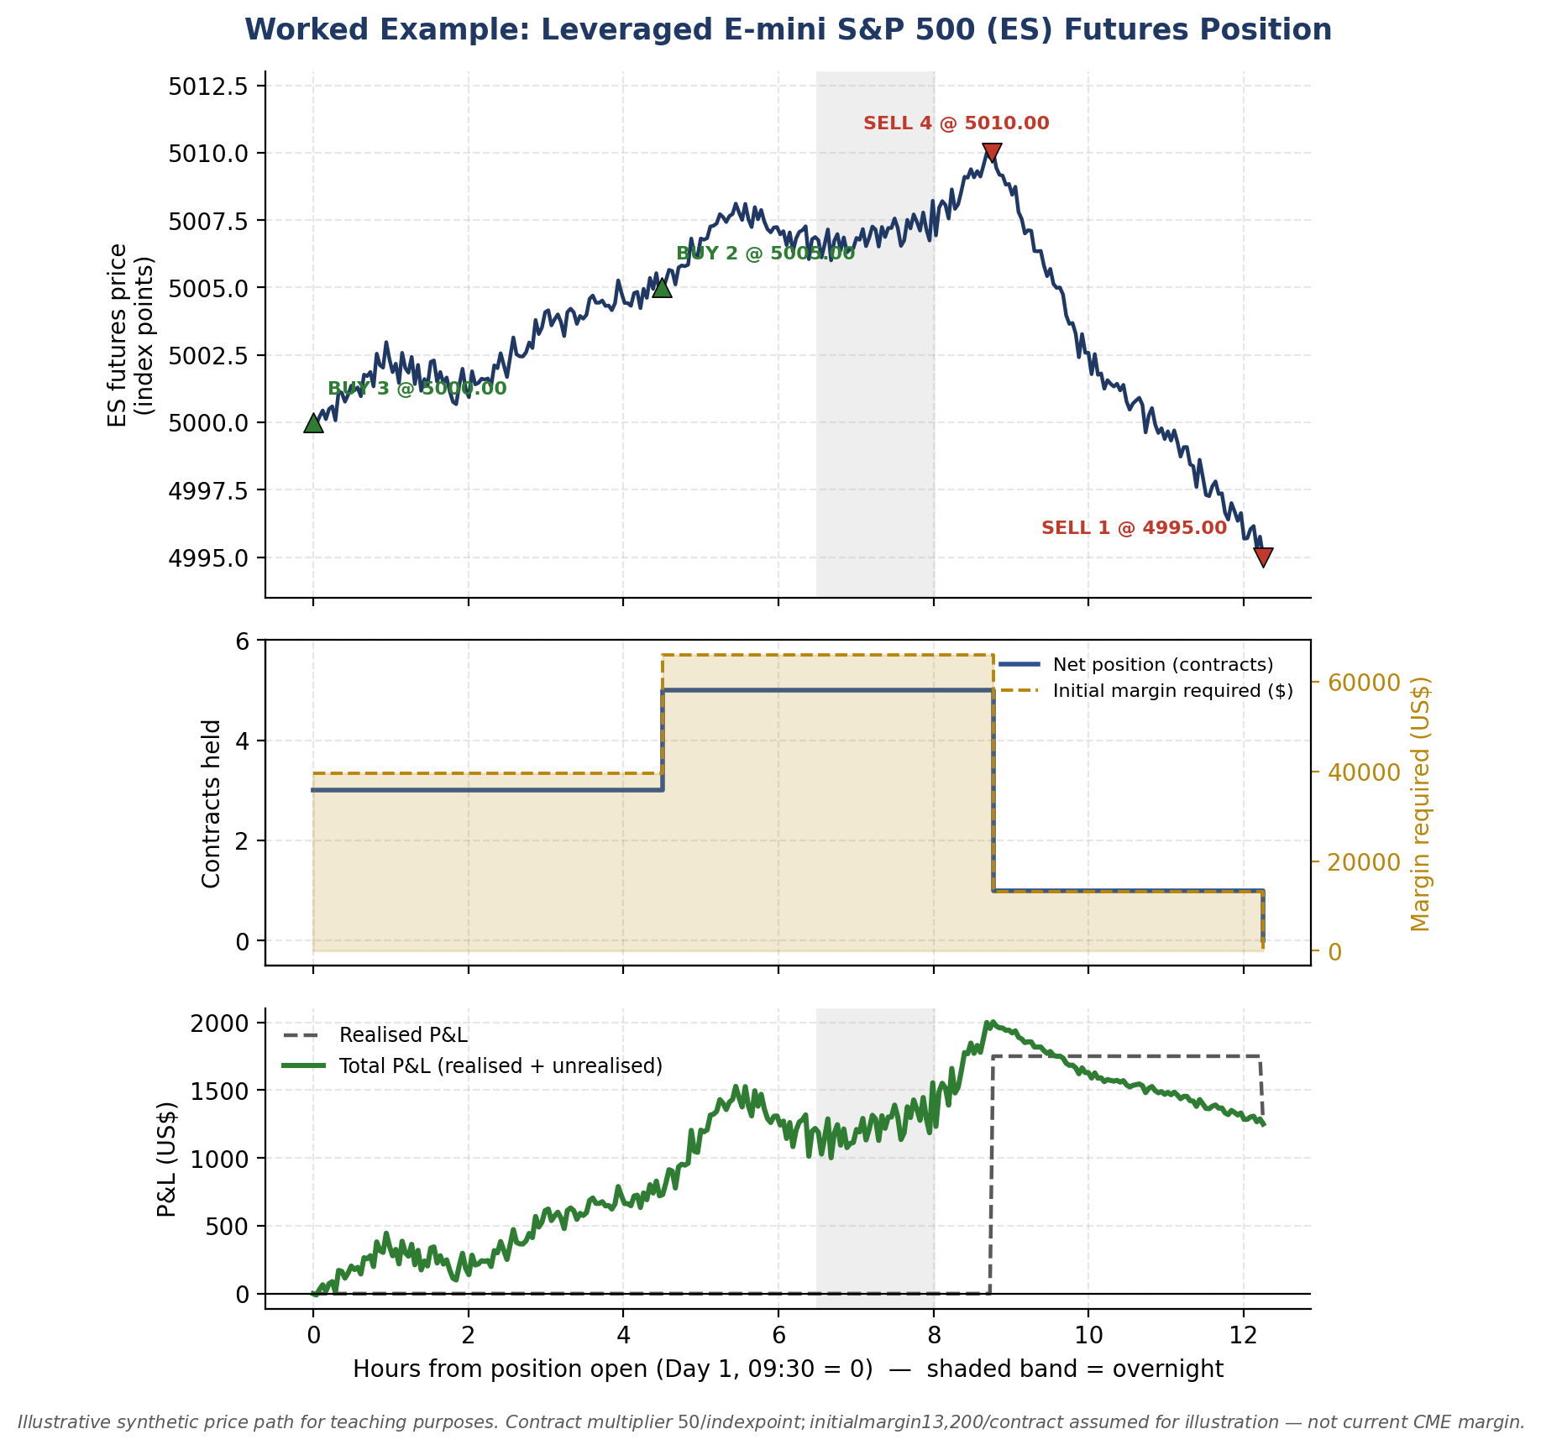
Figure 3.1 — Top: the (illustrative, synthetic) intraday price path with each fill marked. Middle: net position size (left axis) against initial margin required (right axis) — note margin scales linearly with position size. Bottom: realised P&L (step function, changes only on a closing fill) versus total P&L (realised + mark-to-market unrealised), which fluctuates continuously with price while the position is open.
Notional exposure and margin usage over time
After Fill | Net Contracts | Notional Exposure (Contracts × $50 × Price) | Initial Margin Required (Contracts × $13,200) | Effective Leverage (Notional / Margin)
BUY 3 @ 5,000.00 | 3 | $750,000 | $39,600 | 18.9 : 1
BUY 2 @ 5,005.00 | 5 | $1,251,250 | $66,000 | 19.0 : 1
SELL 4 @ 5,010.00 | 1 | $250,500 | $13,200 | 19.0 : 1
SELL 1 @ 4,995.00 | 0 | $0 | $0 | —
⚠ This is exactly the notional-vs-capital-at-risk mistake the exercise is designed to expose
- At its peak, this position controlled $1,251,250 of index exposure while only $66,000 of capital (margin) was posted — roughly 19x leverage.
- A beginner who reasons about “how much money is at risk” using the $66,000 margin figure alone is still exposed to the full $1,251,250 notional move — a 1% adverse move in the index (about 50 points) would cost 5 × 50 × $50 = $12,500, which is 19% of the posted margin, not 1%.

3.4 Leverage and Margin Across Products
The 19:1 leverage in the worked example above is specific to this one instrument and margin level — leverage available to a trader varies enormously by product, jurisdiction and regulatory regime.
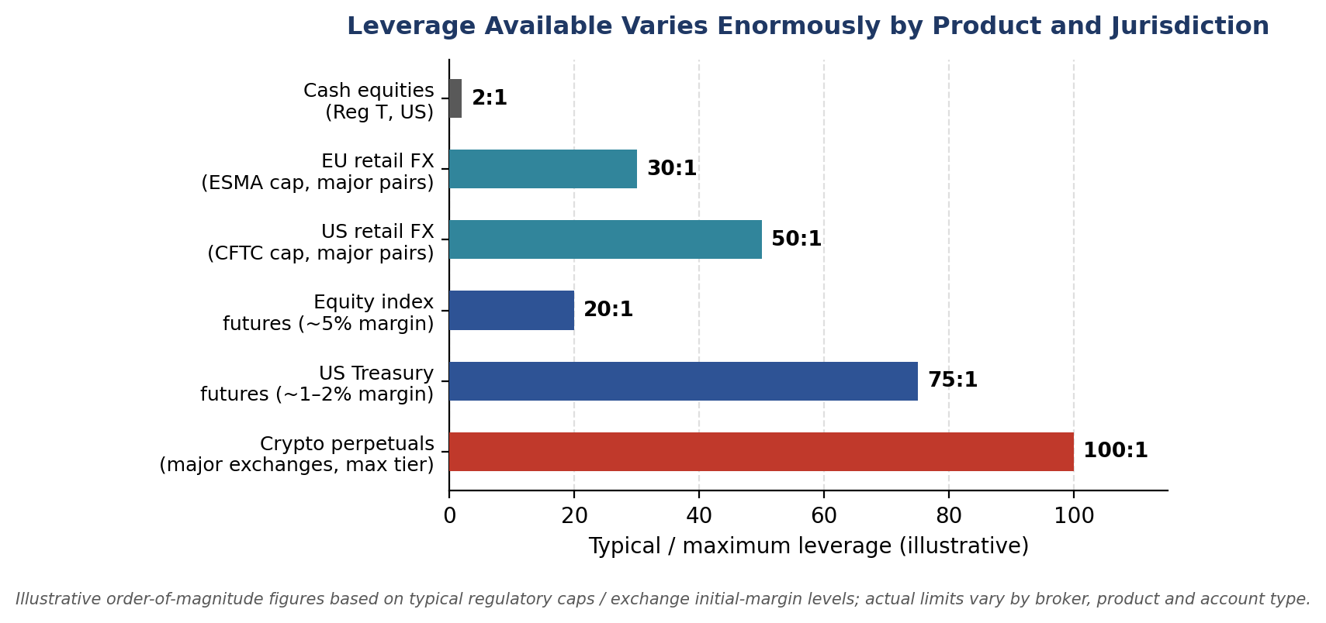
Figure 3.2 — Illustrative typical/maximum leverage by product. Regulatory caps (ESMA for EU retail FX, CFTC for US retail FX) exist specifically because higher leverage mechanically amplifies both gains and losses relative to capital posted.
Margin call mechanics — worked example
Suppose maintenance margin on the 5-contract ES position above is set at $12,000/contract ($60,000 total), and the account's cash equity is exactly the $66,000 initial margin with no additional buffer.
- The position loses money as price falls from the 5,002.00 average entry. Each 1-point decline costs 5 × $50 = $250 of unrealised P&L.
- Equity falls below the $60,000 maintenance threshold once cumulative losses exceed $6,000 — i.e. after a decline of $6,000 / $250 per point ≈ 24 points, taking the price to roughly 4,978.00.
- At that point the broker issues a margin call: the trader must deposit additional funds (or the broker may liquidate part or all of the position) to bring equity back above the initial margin requirement — this is a mechanical, not discretionary, process.

3.5 The Bid-Ask Spread: The Cost Beginners Forget
A theoretical backtest that transacts at the mid-price is silently assuming zero transaction cost on every trade — in reality, a market order crosses the spread, paying the ask to buy and receiving the bid to sell.
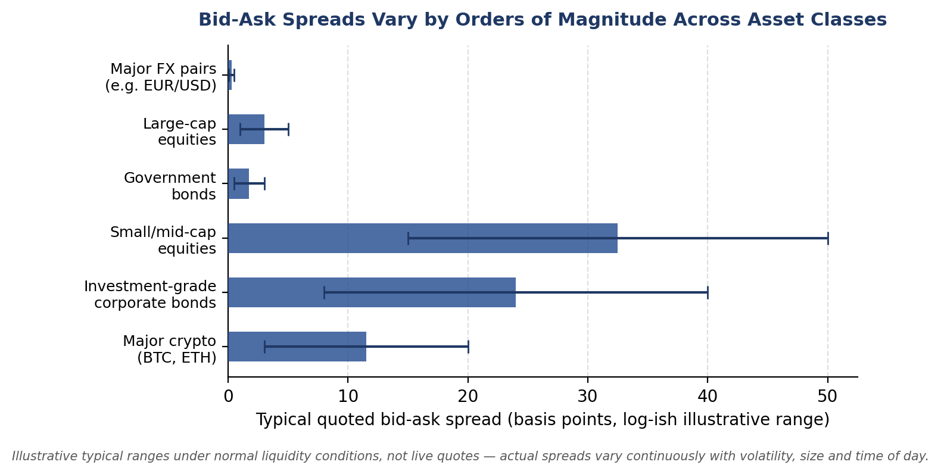
Figure 3.3 — Illustrative typical bid-ask spread ranges. Note the vertical axis spans nearly two orders of magnitude — a strategy's edge that comfortably clears FX-level spread costs may be completely erased by small-cap-equity-level spread costs.
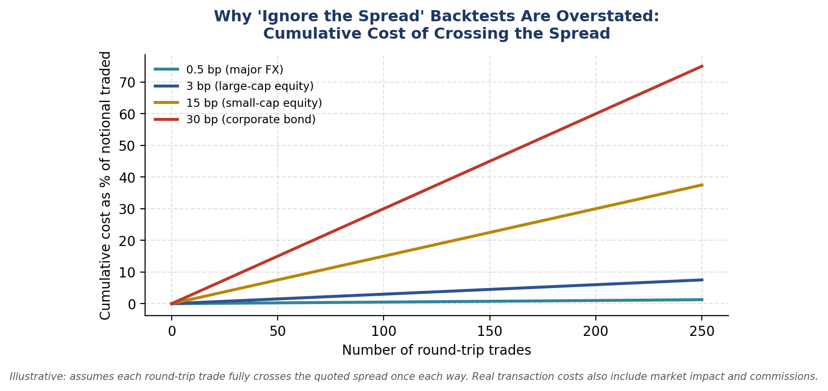
Figure 3.4 — Cumulative cost of crossing the spread compounds directly with trading frequency. A strategy trading small-cap equities 250 times (round trips) with a 15bp spread has paid away roughly 3.75% of notional in spread cost alone — before commissions or market impact.
⚠ Worked example: spread cost on a single round trip
- A stock quotes Bid $49.98 / Ask $50.02 (a 4-cent, or 8bp, spread on a $50.00 mid).
- Buying at the ask and immediately selling at the bid — with no price movement at all — loses $0.04 per share, or 8bp of notional, purely to the spread.
- On a $100,000 position (2,000 shares), that is $80 lost per round trip with zero net price movement — exactly the cost a mid-price backtest silently ignores.

3.6 Funding, Carry and Basis — Worked Examples
Cash-and-carry basis trade
Basis is the gap between a futures price and its underlying spot price. When a future trades above spot (positive/contango basis) by more than the cost of financing and storing the underlying, a cash-and-carry arbitrage becomes attractive: buy the underlying spot, simultaneously sell the future, and lock in the basis as riskless profit (before financing/storage costs).
⚠ Worked example: gold cash-and-carry
- Gold spot trades at $2,000/oz. The 6-month gold future trades at $2,035/oz. Basis = $2,035 − $2,000 = $35, or 3.5% over 6 months (7% annualised).
- If the annualised cost of financing the spot purchase plus storage/insurance is, say, 4.5%, then buying spot and selling the future locks in an annualised carry profit of approximately 7% − 4.5% = 2.5%, before transaction costs — this is exactly the kind of basis/carry relationship referenced as an 'advanced extension' in §1 and §3.1.

Perpetual-future funding-rate carry (cross-reference)
The perpetual-funding worked example in §2.5 is the crypto-market analogue of basis trading: persistent positive funding is economically equivalent to the perpetual trading at a premium to spot, and can itself be captured (short the perpetual, long the spot) as a carry trade, subject to funding-rate volatility risk.

3.7 Common Mistakes — Deeper Look
Confusing notional exposure with capital at risk
As shown quantitatively in the Callout in §3.3, the capital posted as margin is not a ceiling on possible loss — it is a good-faith deposit sized to cover an expected loss range, not the worst case. Losses can, and in leveraged products regularly do, exceed the posted margin, which is precisely why margin calls and maintenance-margin mechanics (§3.4) exist.
Ignoring the bid/ask spread when computing theoretical P&L
This is the single most common reason a promising-looking backtest fails to replicate live, and it compounds directly with trading frequency, as Figure 3.4 shows. Any P&L or Sharpe ratio computed at the mid-price should be treated as an unrealistic upper bound until spread (and, for larger size, market impact) is explicitly deducted.

3.8 Professional Applications
- Position sizing: Professional position sizing (e.g. volatility targeting, covered in Part II Level 3) is expressed in the notional and leverage vocabulary defined here — you cannot size a position correctly without first being precise about what 'size' means.
- Margin management: Treasury and risk-operations functions at any trading firm exist specifically to forecast and manage margin calls of the kind worked through in §3.4, across potentially thousands of positions simultaneously.
- Real-time risk dashboards: Every quantity in the §3.2 vocabulary table — notional, unrealised P&L, margin usage, effective leverage — is a standard field on any professional real-time trading risk dashboard.

